**BLUZELLE Cross Border Payments Solution**

**Mile Stone 2**

**Development Results Document**

Amendment History

|  |  |  |  |  |
| --- | --- | --- | --- | --- |
| Version | Date | Author / Changed By | Status | Change Description |
| 0.1 | 18-Jul-2016 | Krishna Murthy T.S | Initial Draft |  |
| 0.2 | 08-Aug-2016 | Dinesh Kumar | ` | Added details for ML 2 |
| 0.3 | 11-Aug-2016 | Madhupriya | - | Changes made in the FT |

Sign Off History

|  |  |  |  |
| --- | --- | --- | --- |
| Version | Date | Authorisation | Client Authorisation |
|  |  |  |  |
|  |  |  |  |
|  |  |  |  |

**Step 1** :

Login to T24 Browser of BANK A.

Browser URL: <http://ec2-52-16-61-241.eu-west-1.compute.amazonaws.com/R14/servlet/BrowserServlet>

**User Credentials** : SREEDHAR01/123123

**Step 2** :

Click on the Bluzelle Menu

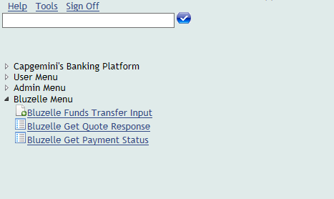

**Bluzelle Funds Transfer Input** – This is used for Inputting the Funds Transfer

**Bluzelle Get Quote Response** – will show the live files where the Get Payment Quote previous responses are captured.

**Bluzelle Get payment status**- Get the status of the quote from Bluzelle.

**Step 3** :

Click on Bluzelle Funds Transfer Input

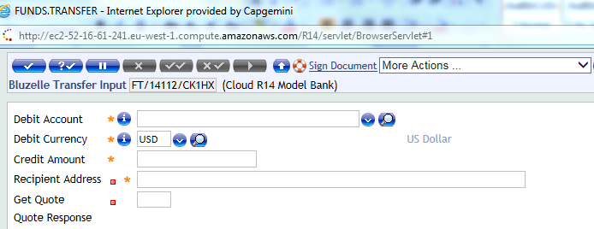

Enter the Payment information as shown in the bottom example:

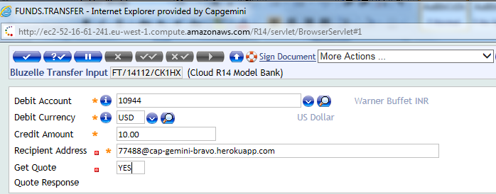

For getting the Quote user needs to type YES on the Get Quote Text Box.

**Step 4**:

Once you click on the Get Quote check box the **Get Payment Quote** API will be called and the response from this will be displayed in the Quote Response field at the bottom. Now click commit button, Accept the overrides, this in turn will trigger the AcceptPaymentQuotation and ExecutePaymentQuotation

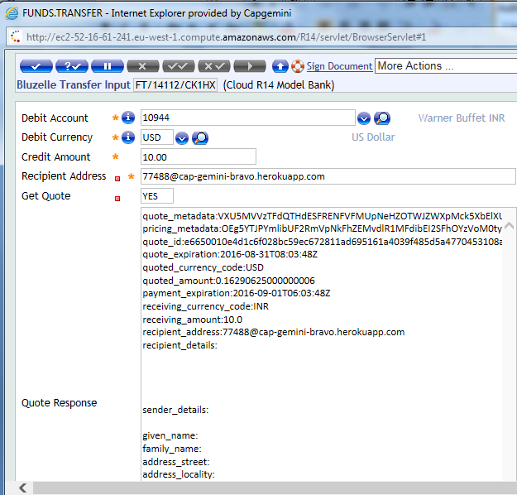

The Txn Complete Message appears

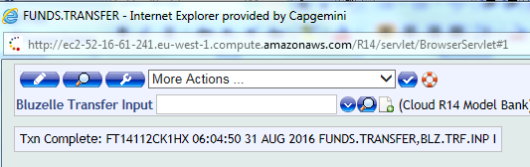

**Step 5** :

A live table to capture this Response -- will be accessible from the ‘Bluzelle Get Quote Response’ in the Menu.

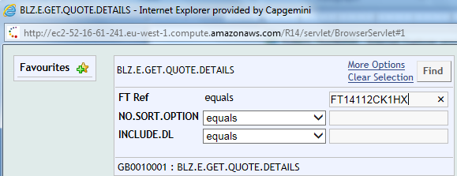

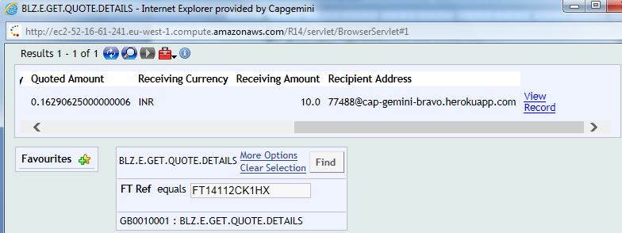

On clicking the ‘View Record’ you can able to view the full response.

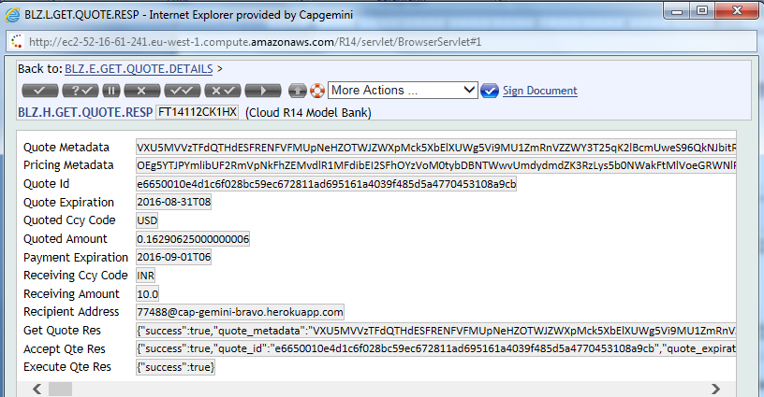

The GetQuoteResponse, AcceptQuoteResponse,ExecuteResponse has been updated.

**Step 6** :

GetPaymentStatus

Click on the helptext menu Bluzelle Get Payment Status to check the status of the quote.

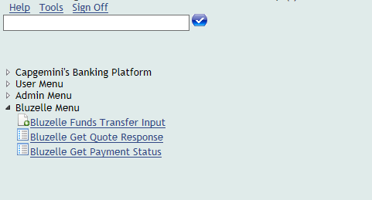

Provide the FT id and click find

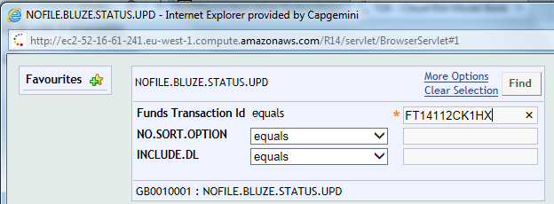

The Response appears as succeeded

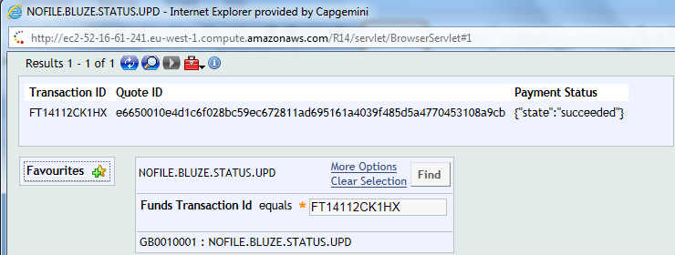

**Step 7:**

Login to T24 Browser of BANK B.

Browser URL: <http://217.115.232.165/R14/servlet/BrowserServlet>

**User Credentials** : SREEDHAR01/123123

Click on the view transaction details submenu in Blockchain T24 menu

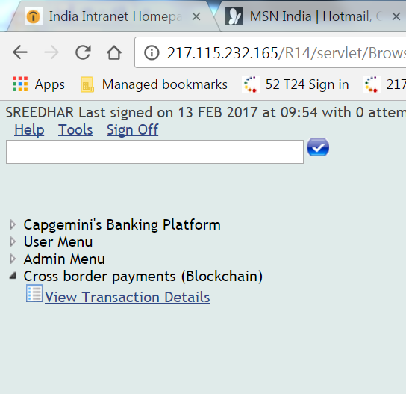

Fillout the below details

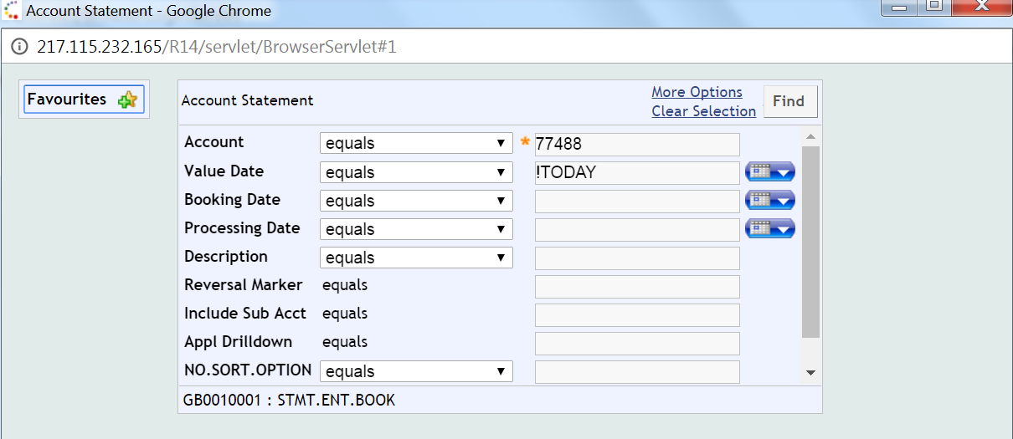

On the receiver side the FT is posted with the initial amount posted in Sender side.

